Outstanding & New Mandate Bugs:

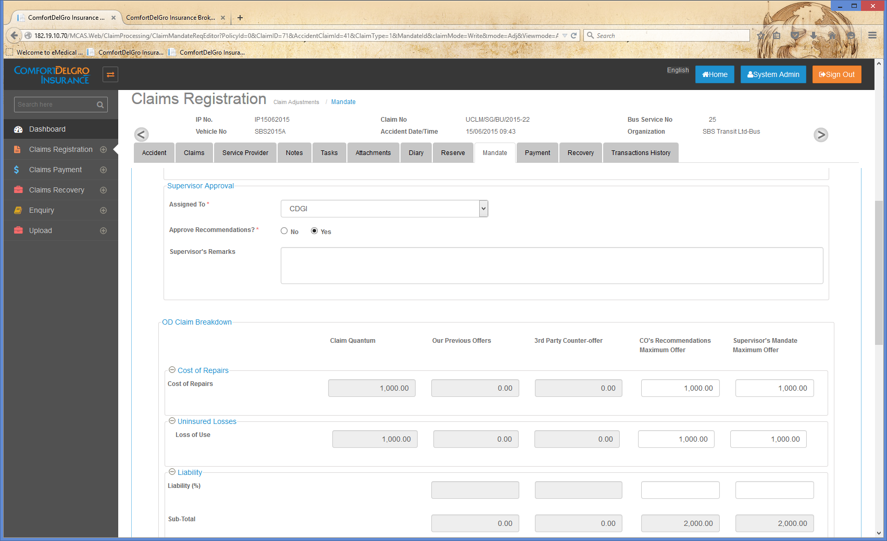

1. **Assigned To Field is still not populating the CO’s name from Claim Officers Field in Accident Claims Tab**
2. **Our Previous Offers, 3rd Party Offer & CO’s Recommendations Maximum Offer Columns should:**
   1. **Open up to users who are tagged to Group with User Role Assignment of Claims Officers and “Claims Officers & Supervisors” only**
3. **Supervisor’s Mandate Maximum Offer should:**
   1. **Open up to users who are tagged to Group with User Role Assignment of “Claims Officers & Supervisors” and Supervisors only**
   2. **Column should populate values from CO’s Recommendations Maximum Offer. Example if I am a Claim Officer and I key in 1000 in Cost & Repairs, Supervisor’s Mandate Maximum Offer should auto populate to 1000.**

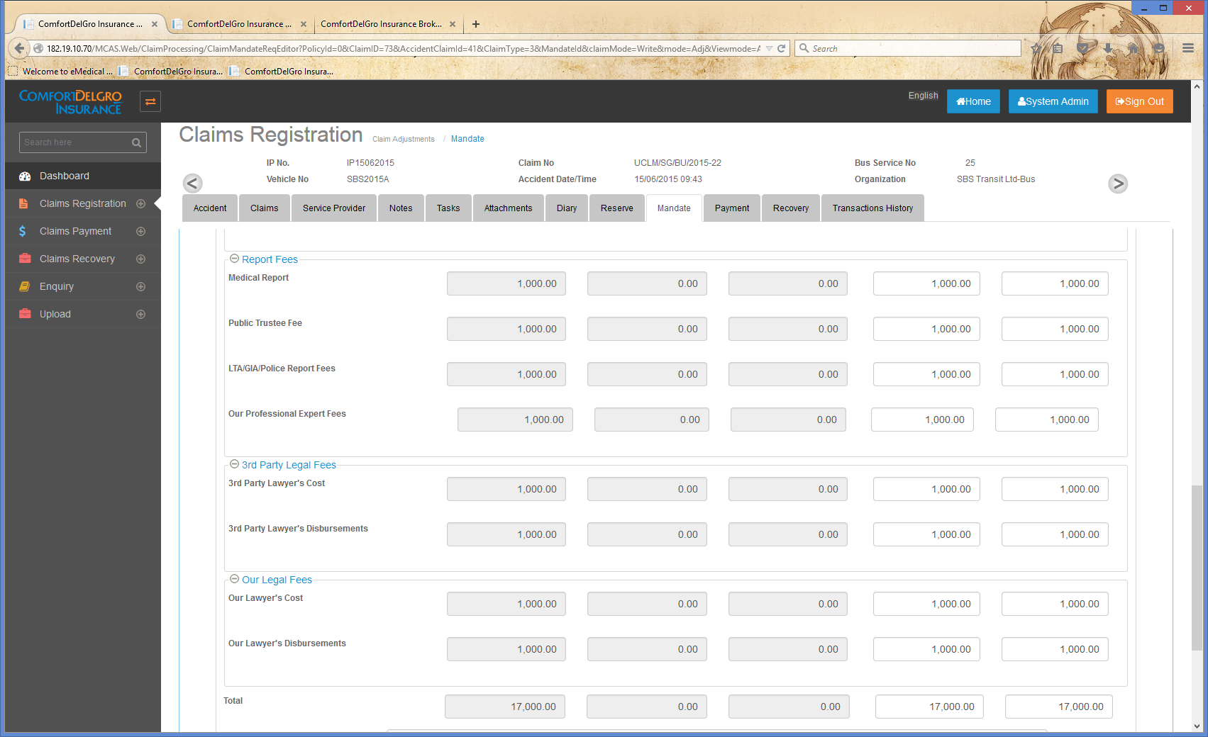

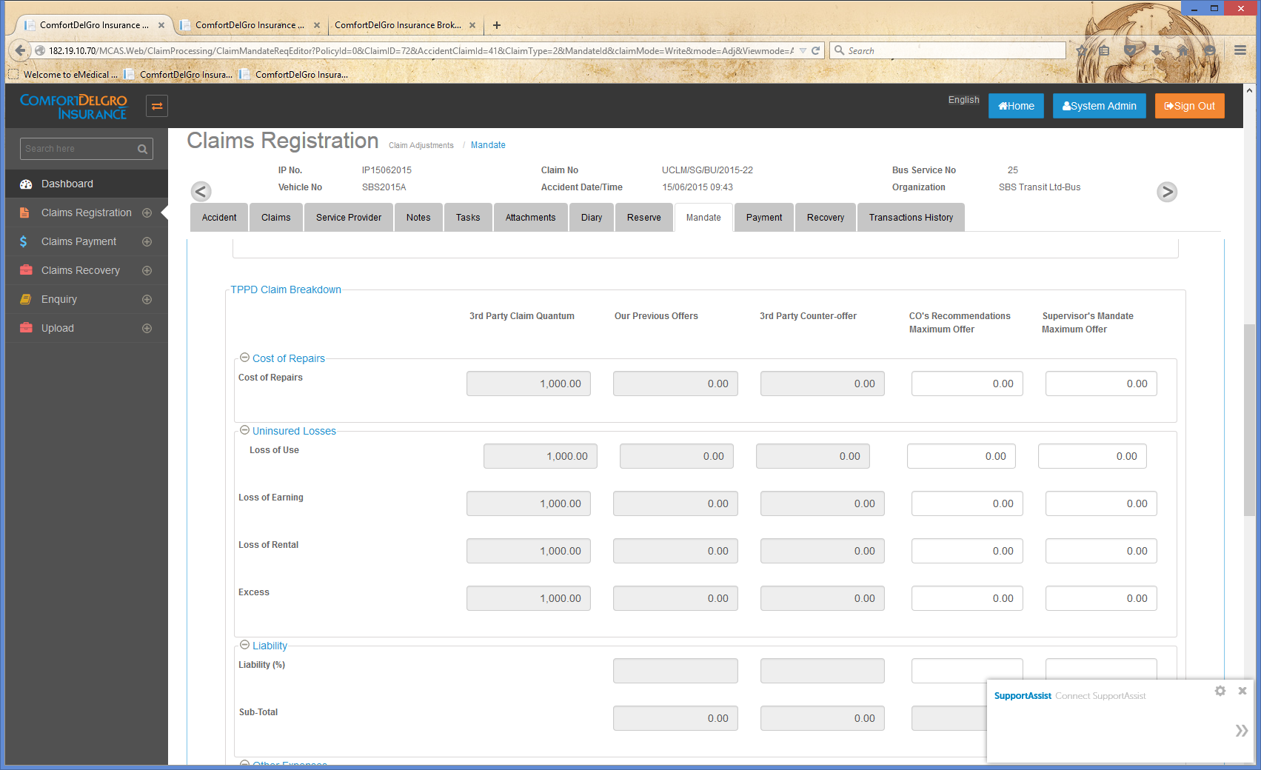

1. **Make the Our Professional Expert Fees Field Text Box in BI Claims the same as size as the rest.**
2. **Make the Loss of Use Field Text Box in PD Claims the same size as the rest.**